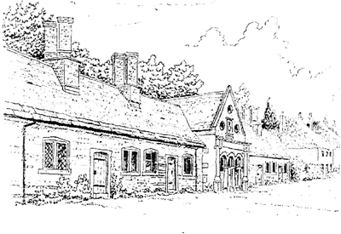
Tregonwell Almshouse Trust
Equality and Diversity
V3.0 Dated 5 August 2026

- Statement of Policy
  - The trustees of the Tregonwell Almshouse Trust (the Charity) are committed to promoting equality and diversity within our policies, practices and procedures. We recognise our responsibilities under the Equality Act 2010.
  - This applies to all aspects of the work of the charity and is promoted through the following values:
    - openness by encouraging and supporting new ideas that will improve the service that the charity provides;
    - respect towards each other;
    - honesty by working in an ethical way;
    - caring with dignity and respect for the individual;
    - support individuals to develop equality and diversity awareness and understanding.
  - The Charity is restricted under its governing documents to provide homes for those in need. Subject only to this restriction, the trustees do not discriminate regardless of age, disability, sex, gender reassignment, pregnancy and maternity, race, religion or belief, sexual orientation, marriage or civil partnership status.
  - The Tregonwell Almshouse Trust does not discriminate on the grounds of disability. However it must be remembered that the Almshouses were originally built in 1647 and are a Grade 2 listed building. The accommodation is not therefore suitable for those with significant physical disabilities as the rooms and corridors for example are too small for wheelchair access and cannot be changed due to the listing status.
  - This policy relates to all residents, trustees, volunteers and visitors.
  - The trustees of the Tregonwell Almshouse Trust are ultimately responsible for ensuring that the policy is implemented.
  - The Charity has designated the Clerk as the person who takes lead responsibility for equality and diversity.
  - The trustees of the Charity will not tolerate discrimination or harassment of any kind. Complaints of discrimination or harassment will be taken seriously and investigated.

- Reporting procedure
  - Any individual(s) who feel that they have suffered or witnessed any form of discrimination should follow the Tregonwell Almshouse Trust complaints procedure.
- Related policies and procedures
  - This policy does not work in isolation. It connects and interlinks with the following policies, procedures and documents:
    - Letter of Appointment.
    - Safeguarding Policy.
    - Resident Handbook.
    - Complaints Policy.

Signed By Chair of Trustees:

Name:

Signature:

Date:

