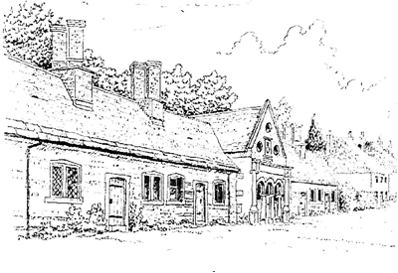
Tregonwell Almshouse Trust
Investment Policy
V3.0 Dated 6 August 2026

- Introduction
  - The Trustees of the Tregonwell Almshouse Trust (TAT) (the Charity) take the view that the financial objective of its investments is to generate a sustainable return to help deliver the objects of the charity.
  - The Trustees of the Charity have agreed that a single reserve fund should be kept and invested which provides:
    - additional income, to that provided by Weekly Maintenance Contributions (WMCs)’ from investment dividends; and
    - a reserve to pay for non-routine (day to day) maintenance such as major roof works or replacement of bathrooms etc.
- Investment objective
  - The overall investment objective is to produce best financial return with an acceptable level of risk while minimising the risk of capital losses.
  - Investments are generally held for the long term however Trustees should ensure that their ability to meet future planned expenditure is not compromised by holding long term investments rather than short term investments.
- Risk
  - The Trustees of the Tregonwell Alms House Trust have considered the following risks and mitigations:
    - inflation and fall in capital values mitigated through investment in appreciating assets or fixed deposit accounts;
    - fall in value or failure of specific investment vehicles mitigated by diversification of assets and investment portfolios;
    - failure of investment counterparties mitigated by requiring a minimum ‘A’ credit rating for deposit taking institutions, and a maximum £150,000 cash deposit per counterparty.
- Liquidity
  - The Tregonwell Almshouse Trust will retain £30k in easily realisable assets sufficient to meet its short-term expenditure plans over (6 months).
- Ethical Policy
  - In line with its ethical policy the Charity will not knowingly invest in:
    - the tobacco industry;
    - armaments;
    - gambling;
    - pornography;
    - environmentally polluting;
    - enterprises that do not encourage equality and diversity;
    - other industries as specified by the Trustees.
  - Note 1: Trustees must be mindful that such restrictions may not be compatible with their duty of care to maximise returns on invested charitable funds. They should also consider whether such restrictions conflict with the objects of the Charity.
  - Note 2: If the Charity holds investments in collective managed funds, then their ethical policy as stated above may not be compatible with that operated by the Fund Managers.
- Management, Reporting and Monitoring
  - All investment decisions will be made by the Trustees collectively, or
    - the Trustees may delegate investment management and decision making to an investment committee, which comprises Trustees with relevant investment experience; or
    - the Trustees may appoint an individual or company as investment managers with discretionary powers.
  - Performance is monitored against agreed market benchmarks as agreed by the Trustees.

Signed By Chair of Trustees:
Name:

Signature:
Date:

