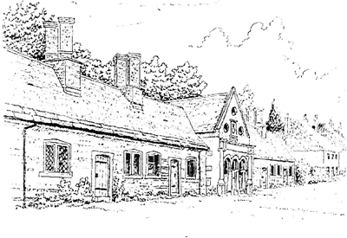
Tregonwell Almshouse Trust
Managing Volunteers
V3.0 Dated 3 August 2026

- Introduction

  - This policy defines the role of volunteers within the Tregonwell Almshouse Trust (the Charity) and how they can expect to be treated.
  - The Charity Commission’s annual return asks if a charity has a volunteer policy.
- Managing Volunteers Policy
  - The trustees of the charity recognise the vital contribution volunteers make to the charity’s aims.
  - Trustees will ensure that all volunteers:
    - are treated equally and fairly;
    - know how they can expect to be treated;
    - know who to contact if issues arise.
- Recruitment and Selection
  - The charity will adhere to its Equality and Diversity Policy when recruiting and selecting volunteers.
  - A description of the tasks involved, time commitment required, necessary skills and actual duties will be provided where appropriate for the type and length of the volunteers commitment.
- Induction and Training
  - All volunteers will have an induction to the charity which will include an overview of the relevant policies and procedures. They will receive a Health and Safety briefing and will visit the Almshouses and, if appropriate, meet the Residents.
  - All volunteers are covered under the Tregonwell Almshouse Trust Third Party Liability Insurance.
  - Where there is specific training required this will be highlighted as part of the recruitment process and if necessary, provided at the expense of the charity.
- Expenses
  - Volunteers will be able to claim reasonable expenses for their volunteering which should be discussed and approved prior to incurring any costs to ensure that it will be reimbursed by the charity.
- Supervision and Support
  - Volunteers will have access to regular support and supervision. This will enable the Charity to identify any training needs and support the volunteer as necessary.
- Health and Safety
  - All volunteers will receive a copy of the Charity’s Health and Safety Policy when required.
- Confidentiality and Data Protection
  - The Charity will comply with its data protection policy in the use of data held on all volunteers.
- Complaints procedure for volunteers
  - The Charity will treat all volunteers fairly, objectively and consistently. Where a concern is highlighted, the charity will ensure that volunteers' views are heard, noted and investigated promptly and aim for a positive and amicable solution.

Signed By Chair of Trustees:

Name:

Signature:

Date:

