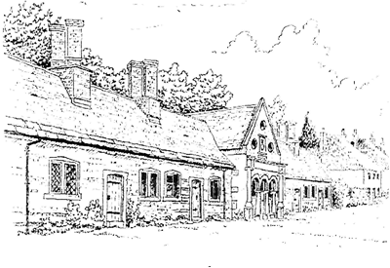
Tregonwell Almshouse Trust
Minutes of Trustees Meeting
Date of Meeting: 12 March 2025

Attendees
Trustees: Mr Rodger Pressland (RP) (Chairperson), Lt Col Susie Castle-Smith MBE (SCS), Rev Lewis Pearson (LP)
Clerk to the Trustees: Mr Mark Castle-Smith (MCS)

No. | Item | Actions / Comments
1 | Apologies  David Duncombe-Anderson  Dawn Wyatt
2 | Minutes of the Previous Meeting:  The minutes of the previous meeting were agreed with the following change:  Item 6: Change date to 2025.
3 | Action Tracker:  The Clerk talked through the Action Tracker spreadsheet. Key items were reviewed and updated as required. | Clerk to maintain the action tracker
4 | Residents’ Welfare:  The Clerk updated the meeting on the residents’ welfare. No significant changes to the welfare issues of our residents were reported.
5 | Maintenance and Upkeep:  The Clerk explained that only minor routine maintenance had taken place since the last meeting, such as repairing water cisterns and that the building maintenance records were being kept up to date. | Clerk to maintain the Action Tracker and building maintenance log books.
6 | Budget and Finances:  The Clerk presented the current bank and investment balances to the meeting.  The Trustees discussed the balance of funds held between the current account and the investment accounts with M&G and decided to keep funds as they were, with a review at the July meeting.
7 | Fundraising:  Susie Castle-Smith briefed the meeting on the Moveable Feast and funds raised for the Church and the Almshouses. Susie indicated that she planned to organise another Moveable Feast next year.  The Clerk explained that he had submitted a bid to the Milton Abbas Street Fair. Subsequently £2000 had been approved by the Trustees of the Milton Abbas Street fair: £1000 for the Reading Rooms (Bid submitted by DDA) and £1000 for the Almshouses. The final amount dependant on the Street Fair profit made).
8 | Clerk to the Trustees General Updates:  The Clerk updated the Trustees on the following matters:  - The Resident’s Handbook had been completed following consultation and had been issued to the residents together with a replacement Letter of Appointment.  - A number of inspections had been carried out as follows:  - Electrical Installation Condition Reports (EICR)  - Fire Risk Assessments  - Legionella Risk Assessments  - TAT Chat was planned for 16 April.  - TAT Tidy was planned for 14 May.
9 | Any Other Business:  The Chair updated the Trustees on the progress made towards deregistration.  The Chair updated the Trustees on the accounts submitted and approved by our auditor.
10 | Next Meeting:  The next Trustees meeting is scheduled for 2 July 2025.  All meetings at 43 Milton Abbas, starting at 1930hrs.

