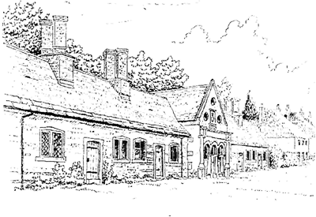
Tregonwell Almshouse Trust
Trustees Meeting: Agenda
Date: 2 July 2025
Location: 43 Milton Abbas
Time: 1930 hrs

Trustees: Mr Rodger Pressland [RP] (Chair), Mr David Duncombe-Anderson [DDA], Ms Dawn Wyatt [DW], Rev Lewis Pearson [LP], Lt Col Susie Castle-Smith MBE [SCS]
Clerk to the Trustees: Mr Mark Castle-Smith (MCS)

No. | Item | Lead | Comments/Decisions Required
1 | Apologies | MCS
2 | Minutes of the Previous Meeting | RP | Approval of the minutes of our previous meeting.
3 | Action Tracker | MCS | Tracker and action items.
4 | Residents’ Welfare | MCS | General update and discussion as required.
5 | Maintenance and Upkeep | MCS | Works since previous meeting / Quinquennial Review.
6 | Budget and Finances | MCS  RP  RP | Current bank account and investment balances  Review funds held in each account.  Approval for capital spend on upkeep.
7 | Fundraising | SCS | Street Fair and next Moveable Feast.
8 | Clerk to Trustees General Updates | RP | Web site, TAT Tidy and TAT Chat feedback, waiting list for accommodation.
9 | Complaints | MCS | Ombudsman requirements and Complaints Policy.
10 | Any other Business | RP
11 | Next Meeting | MCS | 12 November 2025

