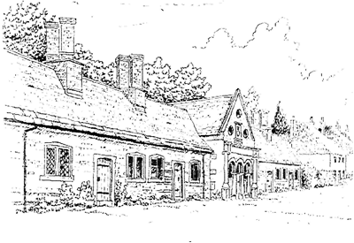
Tregonwell Almshouse Trust
Minutes of Trustees Special Meeting
Date of Meeting: 12 March 2025

Attendees
Trustees: Mr Rodger Pressland (RP) (Chairperson), Lt Col Susie Castle-Smith MBE (SCS), Rev Lewis Pearson (LP)
Clerk to the Trustees: Mr Mark Castle-Smith (MCS)

No. | Item | Actions / Comments
1 | Apologies  David Duncombe-Anderson  Dawn Wyatt
2 | Proposed Changes to the Charity Commission Scheme  The Chairperson summarised the proposed amendments to the Tregonwell Almshouse Charity Commission Scheme which had been discussed at the previous Trustees’ Meeting.  The Chairperson asked if there were any comments on the proposed changes by the Trustees attending; no comments were made.
3 | Vote to Agree the Proposed Changes  The Chairperson asked for a vote to support the proposed changes.  The changes were unanimously supported, with the three attending Trustees approving the proposed changes. | Vote taken
4 | Clerk Actions  The Chairperson asked the Clerk to submit the proposed changes to the Charity Commission for approval.  Post Meeting Note: The Clerk submitted the proposed changes to the Scheme, which have been approved and adopted by the Charity Commission. The Charity Commission does not produce a single unified Scheme with the approved amendments included. To understand the complete Scheme, the original Scheme must be read, followed by approved amendments. The current entry on the Charity Commission website shows the amendments as follows:  ‘SCHEME OF THE 9 DECEMBER 1999 as amended on 12 Mar 2025’ | Clerk
5. | Meeting Closure  There being no further business, the Chairperson closed the meeting.

