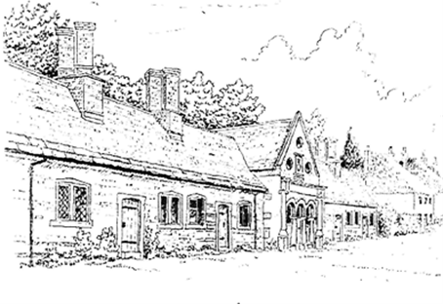
Tregonwell Almshouse Trust
Reserves and Restricted Funds Policy
V3.0 5 August 2026

- Introduction
  - The Trustees of the Tregonwell Almshouse Trust (the Charity) take the view that reserves are essential to maintain the ongoing viability of the Charity.
  - The Trustees of the Charity will consider whether it is appropriate to add to the reserve from any excess of income over expenditure from time to time and at least yearly. Reserve fund decisions are to be formally minuted, following agreement at a Trustees meeting, which may be called as an extraordinary meeting if a time critical reserve fund decision needs to be made out of the normal trustee meeting timescale.
- Restricted Funds
  - Restricted funds are in addition to the general reserve fund as described above. The nature and amount of any such Restricted funds may impact upon the Reserves Policy. The starting point for calculating the appropriate reserve will normally be unrestricted funds, however part of these may not be readily available or realisable for spending and may not be available. This may include certain tangible fixed assets and any programme related investments. Currently the Tregonwell Almshouse Trust does not hold any Restricted funds and would generally seek to work with any donor for such funds to remain as general reserves or working capital unless they have been requested for a specific project or programme of work.
  - Donations made as Restricted will not be kept in a separate account, but will generally be added to the reserve fund, unless they have been donated for immediate use. The Clerk to the Trustees will keep a record of all restricted funds, together with their donor, held as working capital or within the reserve fund to ensure they are used as they donor specified.
- Level of Reserve Fund
  - The Tregonwell Almshouse Trust recognises the need to have sufficient funds in reserve readily available or investments convertible into cash to cover day to day expenditure including one off costs for major repair work, and especially if there is a reduction in Weekly Maintenance Contribution (WMC) income following the departure of a resident pending new residents being appointed.
  - In order to mitigate these risks, the Trustees have calculated that reserves of approximately £156k would be needed to allow the Charity to operate for at least 12 months without income from WMCs as well as providing cover for one significant unexpected repair charge. The reserve is also designed to provide funds for regular refurbishment of each Almshouse. This amount is calculated as follows:
    - Loss of WMCs for one year: £16k
    - One off unexpected repair: £100k
    - Regular refurbishment: £40k
  - The Tregonwell Almshouse Trust recognises the need for investment income to meet any excess of costs over the WMC and other income and the reserve fund will be invested in accordance with the Tregonwell Almshouse Trust Investment Policy.
- Approval
  - This policy has been approved for issue by the board of Trustees of the Tregonwell Almshouse Trust.

Signed By Chair of Trustees:

Name:

Signature:

Date:

